INDIVIDUAL PROGRESS REPORT 1
Student Name: Md Al Shariar MINAN
Student ID: 12267196

Contents
1. Overview 2
2. Evidence of Individual Contribution 2
3. Progress in Achieving Project Goals 5
4. Reflection and Professional Accountability 5
5. Planned Next Steps 5
6. Professional Conduct and Engagement 6

1. Overview
In this report, my personal development during the project project will be shown with regard to the penetration testing of sensor network related to compliance reporting. This project aims at analyzing the performance and security of a virtual IoT sensor network.
The tasks involved in this stage were to test and analyze the behaviour of the network under varying conditions. This involved putting stress and disruption on the network by simulating high traffic conditions and node failures.
The work done to date illustrates the practical testing of the network and offers an insight into the performance and reliability of the network.

2. Evidence of Individual Contribution
My work was to test and analyze the sensor network in Cooja simulator. The tasks that were done included:
- Added more motes to create a high traffic situation.
- Monitored the packet transmission during heavy load conditions.
- Observed network congestion with Radio Messages window.
- Conducted node removal in the course of the simulation to investigate network resilience.
- Monitored routing behavior and communication behavior following node failure.
- Examined the way the network responds to changes in topology.
These undertakings illustrate my involvement in penetration test and evaluation of the project.
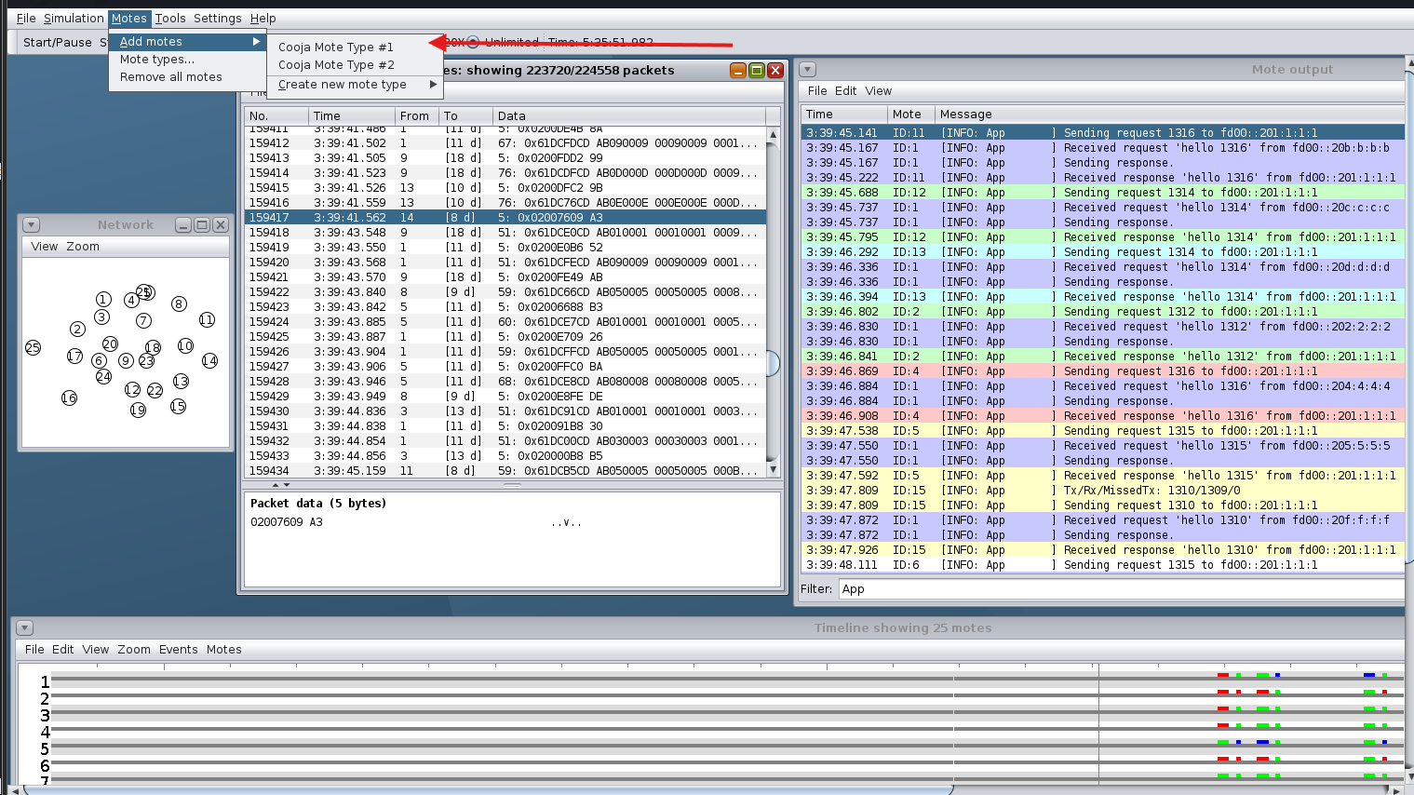
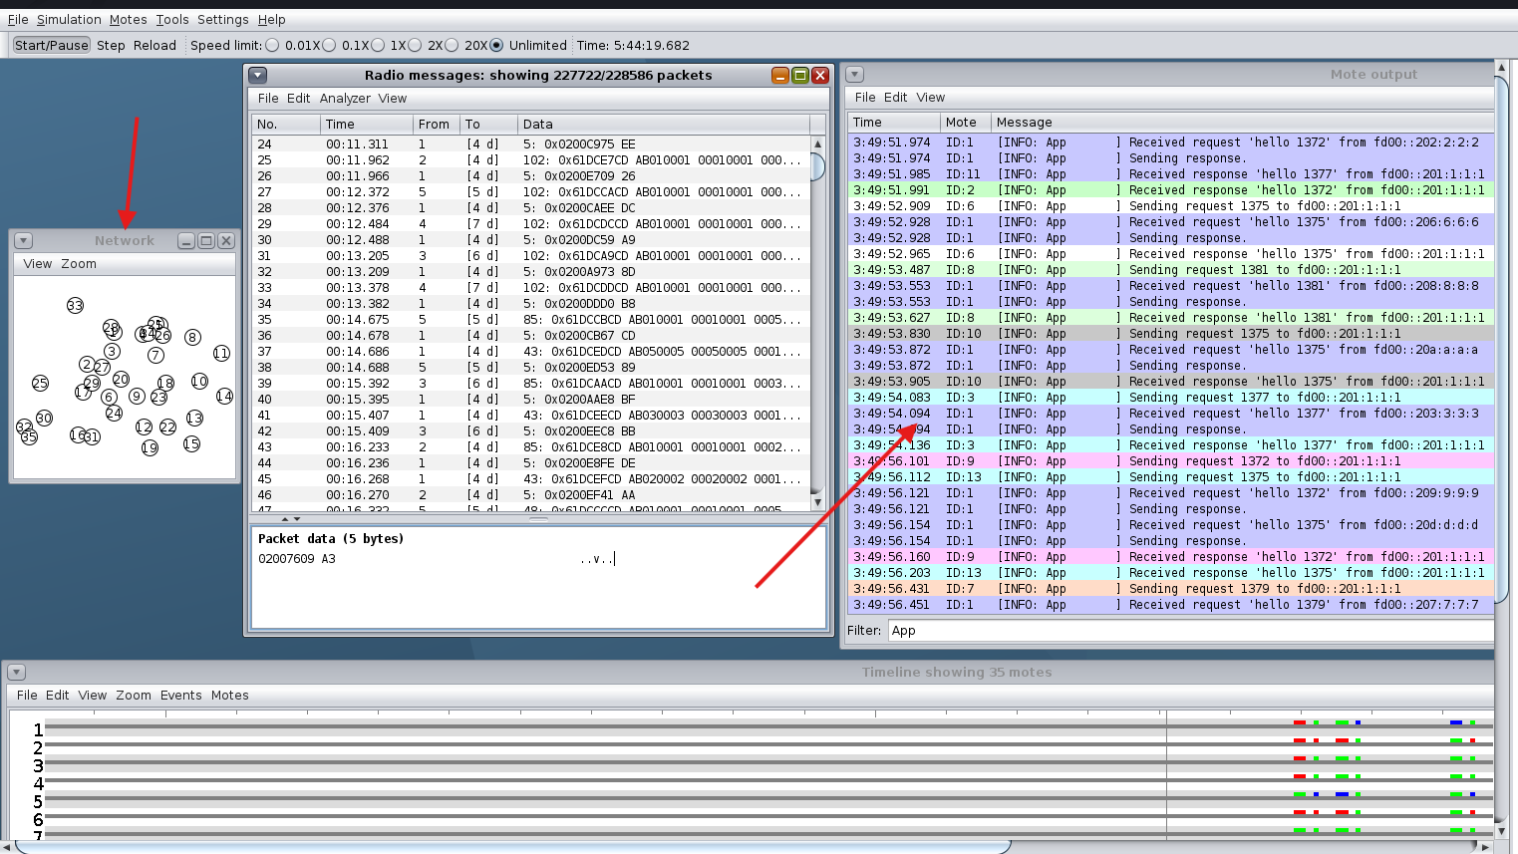
Figure 1 Increased Traffic in Network (Flood Scenario)
These Figures represents the network when there is a high level of traffic. The volume of packet transmission was greatly increased by addition of nodes. Radio Messages window shows a huge amount of data being transferred in the form of packets, which means that the network is congested and heavily loaded.
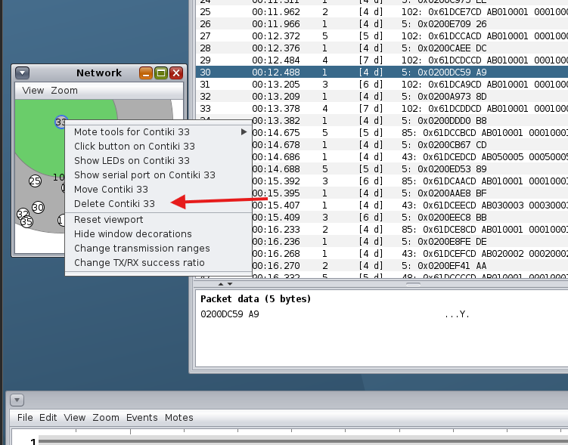
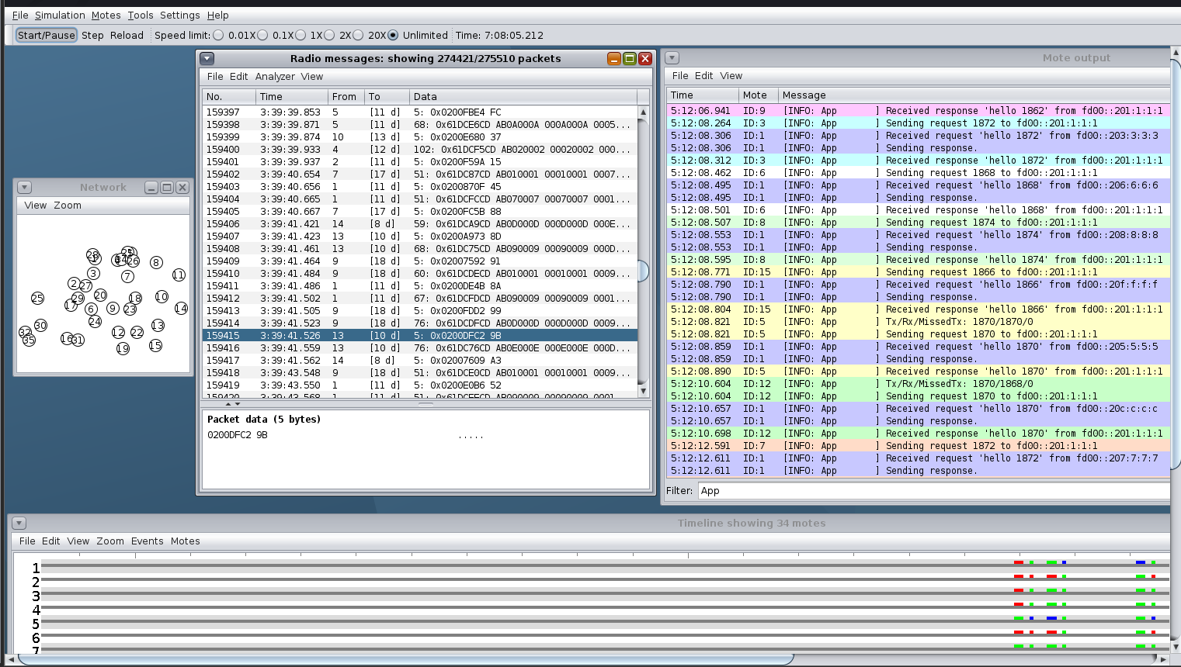
Figure 2 Network Behavior After Node Removal
This figure demonstrates the deletion of a node in the course of the simulation. The network still continues to work, however, routing and communication changes can be noticed. This illustrates the way the network can adjust to the failure of the nodes and shows that it can be unstable under dynamic conditions.

3. Progress in Achieving Project Goals
The network has been tested in various conditions and this has been achieved successfully. The network has been tested in normal and stress conditions and has been successful.
The flood case showed that an increase in the number of nodes is accompanied by an increase in traffic and congestion, which impacts the overall performance. The node removal case demonstrated that the network is able to adjust to topology changes, but there can be transient instability.
The findings can be used to comprehend the advantages and disadvantages of the RPL-based sensor network and help in fulfilling the project goal of performance and security analysis of the network.

4. Reflection and Professional Accountability
In this stage, I encountered difficulties in coming up with meaningful test situations in Cooja simulator. First, it was challenging to model high traffic and see realistic network behavior.
Experimentation was used to solve these issues by varying the number of nodes and seeing how the number of nodes affected the transmission of packets.
This process helped me to gain a deeper insight into the behavior of the network when subjected to stressful conditions. I also developed my analytical capabilities by analysing the results of simulations and finding patterns in communication.
This has enhanced my applied understanding of concept of penetration testing in the IoT setting.

5. Planned Next Steps
The second stage of my work will be based on further analysis and testing. The activities planned involve:
- Conducting further stress testing using alternative node configuration.
- Learning more about routing behavior.
- Determining the possible vulnerabilities of the network.
- Supporting the report on findings in the final report.
- Observations mapping onto cybersecurity frameworks like NIST.

6. Professional Conduct and Engagement
I have been involved in testing and analysis phase of the project and have done all the tasks assigned to me in a responsible manner. The environment in which all the activities were done was controlled simulation, ensuring ethical and professional practices.
My input is in line with the project requirements and is showing significant progress towards attaining the project objectives.

